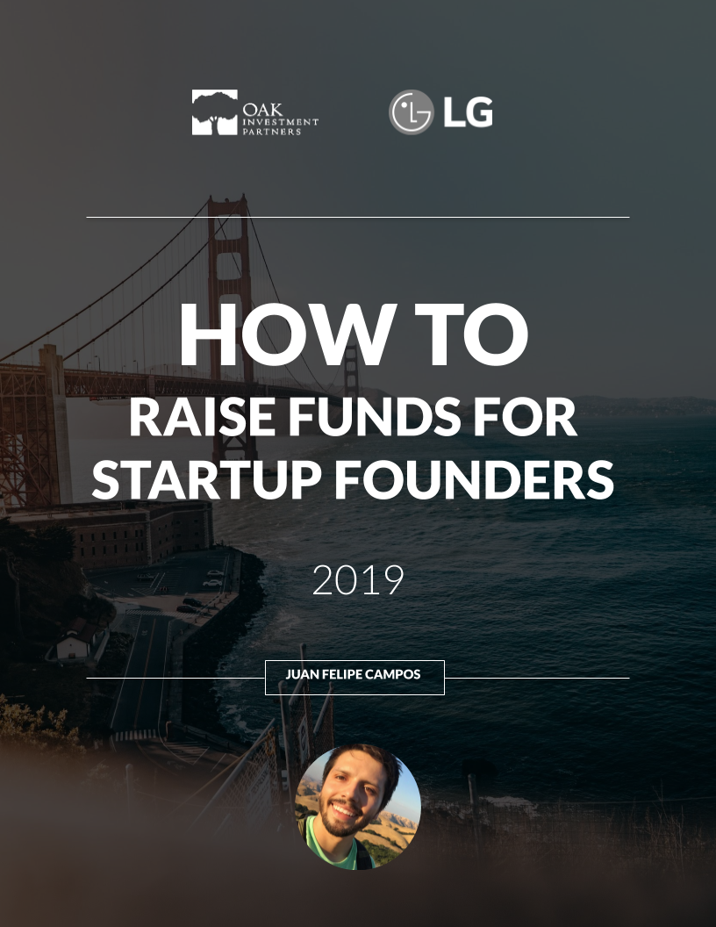

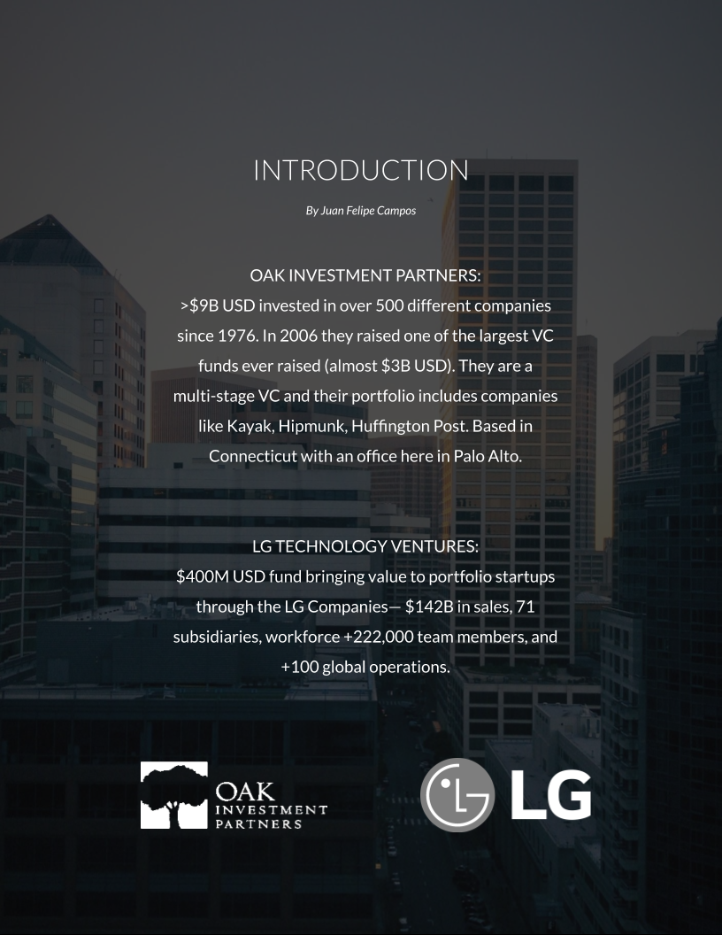

## READ THIS FIRST

Hey everybody! I’m Juan Felipe Campos, Partner/VP of Tech at Manos Accelerator via Google Launchpad. Over the last 3 years of living in Silicon Valley, I’ve taken lots of notes about raising institutional money for tech startups. I hope this serves as a valuable resource in your journey to become venture-backed.

**Why is this a Live eBook?**

As I continue to grow and learn about fundraising, I’ll update this document. It’s my goal to make it the most valuable resource of its kind in the world. By creating it as a live document, we can all benefit from new lessons and perspectives. Feel free to share your own lessons as a comment.

**Questions?**

You have commenting access.

Leave a comment any time you have a question. I’ll do my best to answer them here directly and hopefully others will join, too.

Here’s to your succes!

Enjoy,

Juan

[LinkedIn](https://www.linkedin.com/in/juanfelipecampos/) | [Twitter](https://twitter.com/juannikin) | [Instagram](https://www.instagram.com/juannikin) | [Facebook](https://www.facebook.com/jfcampos)

## 1. For international founders

Half of the founders in Silicon Valley are foreign born.

Preparation is important before you come here. If you’ve received investment from a credible investor in your country, that helps you here. Get customer traction in your home country. If you come here with just an idea, you’re not taking advantage of what’s available in your home country.

“Liability of foreigness (meaning the danger in doing something new/foreign)”. If they don’t know you within this tribe of Silicon Valley, then it’s difficult for them to justify you to their investment community. They’re looking for signals: that you went to a specific school or worked at Google. Sometimes you don’t have it. Some investors look at those signals and let it guide them. I think the best ones do their due diligence. If I were you, I wouldn’t stay with convincing the VC’s. I’d start with convincing the local market (companies). They only want the best, so if you get into every unicorn in the valley, they’ll take your meeting. This is the strongest signal there is: core your corporate clients.

That’s how you translate your success into Silicon Valley terms. If you have the clients, they’ll take notice and disregard any other “shortcoming”.

Do you have to incorporate as a Delaware C corp?

At Oak Ventures we have a global mandate to find the best companies— period. If it doesn’t make sense to incorporate in the US, then I’m ok with it. We’ve invested in pretty much any offshore jurisdiction where it has made sense.

If you’re in China, no. If you’re in Delaware, Cayman, etc it’s ok. All European are ok.

## 2. On the challenge of raising funds

There’s a lot of literature about product feedback and customer acquisition but fundraising is one of the least optimized processes you’ll have to speed up.

On finding the right investor:

Start by looking at who invested in your competitors or synergetic startups. Ping synergetic startups asking for intros to their investors. The more you learn about who invested in your competitors, the easier it will be to find the right VC for you. Learn those investors’ thesis intimately and find other VC’s with the same thesis.

Do due diligence on the VC. Ask portfolio CEO’s how the VC is. Not just the firm, but the individual.

On talking to investors:

Value time, your own and theirs. Research what they invest in.

On the process of getting funded:

Do your homework:

Full-time job for 3-6 months. Dong-Su

They’re looking at 10-50 deals per week. Make an impression in your deck.

Then due diligence. Financials business plan, etc.

Negotiate term sheet.

Form a syndicate of investors.

Close.

It’s a myth that VC’s write a check on a napkin.

You’re also trying to figure out who YOU want to work with. If they’re that quick to write a check, chances are that they’ll never talk to you again. Good or bad. Especially when you need help.

Connect with 50, you’re lucky with 20 meetings and even luckier with one guy to lead.

## 3. On when to fundraise

You should always be fundraising.

Always identify the right people that you’re interested in building a relationship with and then do that. That can connect you with other people. If your VC’s are in your general area of what you’re doing, it’s their job to know what you’re doing. You make their job easier by putting yourself in front of them. They’ll give you feedback and it’s up to you to determine if the feedback is valuable or not.

## 4. On how to talk to investors

To VC’s: what can you do for a startup like mine? Ok, there’s probably competition if they want to know.

On communication with your investor:

What we provide for startups depends on the stage and kind of VC. Some are very corporate and want monthly reports and they have to do compliance and reporting on their side. It’s all about the personal relationship between the person that led the round and the CEO. Angel doesn’t want you spending time on anything that doesn’t help you. It’s a lot more scaleable if you write an email etc once a week or month and send it to all your mentors advisors and VC’s. I don’t need documentation to make sure that you’re on track, but when a new VC comes in, they need documentation to do due diligence. How would a new VC know how you pivoted or learned. That helps them know you’re running an organization and not just yourself and your friends.

You should feel like there’s someone on the board that you can have brunch with. If you don’t have that kind of relationship, you should fix it. You should be in line with the investor and they should want to have that level of access to you too. I like CEO’s that leverage their VC’s. I understand some don’t— but I like it when they do.

What gets a second conversation?

It’s hard. Work on it and try different things. It’s more chemistry than anything else. Easier if you’re introduced by someone reputable that investors trust. That gets you started at the fifty yard line. A mentor etc who is reputable in Silicon Valley.

I’ll have a list of questions ahead of time. I’ll ask people to send me everything ahead of time. Just be aware that time is super limited so make sure the right information is presented concisely.

## 5. On how investors choose who to invest in

Can I help this company? I don’t care about financials. If there’s nothing I can do, then I’m a passive investor. If you do that then just put the money in the stock market so you can pull it out.

What stage are they in? If they’re a little bit too early I want them to connect with my other companies so they already start adding value and my companies can do due diligence in them. If they’re too late, there’s nothing I can do. I can connect my portfolio to them.

Finances ties to the sector. Every space has metrics that are meaningful. You need to figure out what the story is and why those metrics make sense. These metrics represent you creating value and you capturing that value. It’s your job to understand where they are with that.

Corporate VC’s can add value in different ways. Remember that.

For us, the decision is financial and strategic. If we can show that a company that we invest in creates synergies with our other companies, then we’re successful.

Our LP’s only want the financial success me for me, it’s questionable to get a great return but bad relationship. The VC’s care about the long run.

The vast majority you pass on just have nothing to do with what you do. It’s about the alignment of the vision between the founder and VC for the harder ones. If it works, then the question is if this opportunity will return your entire fund. We play in a field where most are not unicorns anyways.

If I can’t trust the CEO, that’s a big flag. Looking for character here. What does your cap table look like? Keep it simple. 7 investors investing in equity or something like that. Try to clean it up before trying to raise money.

## 6. On how to learn more about fundraising

You have to be a leader and a well rounded leader and able to surround yourself with complimentary people. I think it’s overlooked to invest in yourself, your culture (what rules and vibe), it also involves your family. Team building and leadership books. They’re often overlooked areas. They’re not more important, just overlooked. Personal side of being a leader.

Learn from other people. Entrepreneurs, investors, mentors. Reach out. This is much faster. They’ll more freely give you advice.

## 7. On company valuations

Value is what a customer is willing to pay.

It could be that that’s all they have to pay. It’s complex and varies.

Lawyers have the mindset and training of “how to divide the pie”. Business people think how do I grow the pie. Don’t have your legal team just close it. It’s about finding how to maximize this opportunity together. Be careful. Sometimes they just want to know your numbers. Pricing is really important. Don’t underprice just so you can sell. You’re leaving a lot on the table if you do that. Price so you can grow.

You want to show that one plus one equals three. You need to show that the acquisition fits you within the company and how that will exponentially increase the company’s momentum.

Valuations: get informed. There’s generally a range and a variation of that range. As long as you’re within that range, there can be a conversation. VC’s want something that is fair. Ultimately the investors know that if they’re putting lots of cash at a low valuation, they’re diluting the founder so much that they’re killing the incentive. If they set it too high then it makes it harder for founders on the next raise. Don’t think in terms of that valuation but think in terms of the story that it will tell later and how the dots will connect in retrospect.

Don’t overthink the valuation. It’s not as important as you may sometimes think. Go for the most value, not for the most cash. Not just the highest bidder.

## 8. Step by Step

The moment you start fund raising, you begin running two product lines.

1. Your flagship product that you sell directly to customers (what most people know you for).

AND

2. Your company.

Investors are not clients of your product, they are looking at your whole company as a separate product that they may want to purchase part of.

This means they look for nice "features" in the business like: founding team, traction, business model, revenue, etc.

Here are 10 more things you should know about fund raising:

1️⃣ Build a sales funnel of investors just like you would for your product. Expect to talk to at least 150 QUALIFIED investors.

2️⃣ 100 pitches to get 3-5 commitments is not unusual. This means you'll get rejected ~95% of the time– even with a highly qualified and pre-vetted investor list. Prepare for this.

3️⃣ Find investors on Crunchbase, PRHub, InsideVenture, VenturePulse, Quora, Techcrunch, Medium, Pitchbook (paid), CB Insights (paid), Foundersuite, or LinkedIn.

4️⃣ Asking someone for "investor intros" is too broad of an ask. If you don't know what you want, they won't either. Do your homework in advance and ask for intros to specific people who you think would be a good fit to increase the likelihood of an intro.

5️⃣ Avoid investors who have: invested in competitor startups, are low on funds, have done no recent deals, invest in a different sector/stage/location than you're in, have bad reputation. Diligently cut down your list at the research stage for a better investor conversion rate.

6️⃣ Create a tracking system or CRM to keep track of relationships as they move from "new lead" to "💸 committed" or "⛔️ declined". Remember, you're selling a part of your company. This is a sales process.

7️⃣ Do intros in parallel– you want to talk to as many qualified investors as possible at once. Build momentum!

8️⃣ Send regular progress updates to all investors who haven't explicitly told you "no". This creates FOMO in your favor. Investors have a tendency to want to be the last ones to join. They won't know they're last if you don't tell them others are jumping on board.

9️⃣ Use a tool like Foundersuite or Docsend to see who's viewing your deck (and plug emails into re-targeting so you can infiltrate their attention).

🔟 When you see momentum building, go for the close! Ask for interest level and next steps. It can take 3-6 meetings before you get a term sheet, so expect to follow up frequently and move the relationship along. This is your responsibility. Don't let up until they say "no" or you have money in the bank 😊

## More Thoughts

Make sure you’re reaching out to the right investors. If it doesn’t fit the right investor, you’ll be a pass and a No.

Talk to your peers and get relevant intros.

Make sure you have traction in your home country. They don’t know how to assess your home traction, so attract clients here and break into the ecosystem that way.